Cadentown Historic Site
Supporting Images

Image A: Map of Property
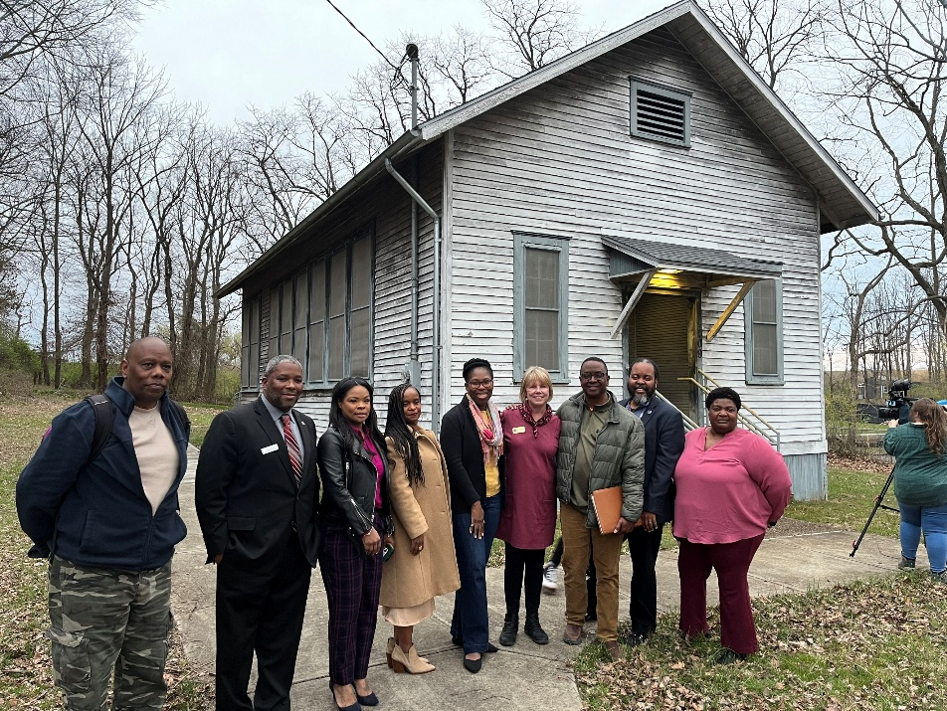
Image B: Members of Steering Committee in front of Cadentown School

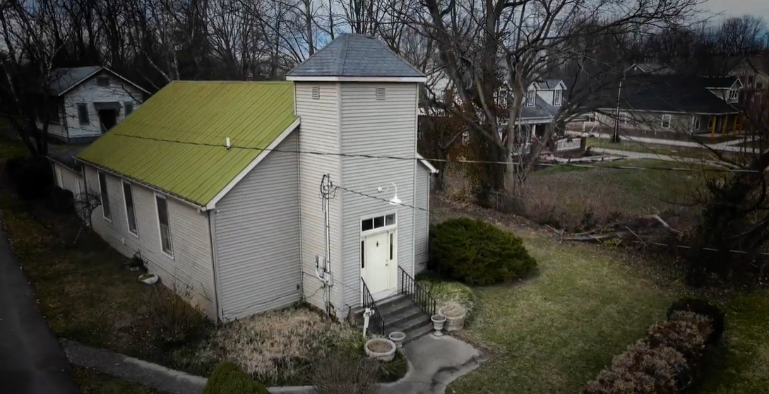
Image C: Cadentown Church

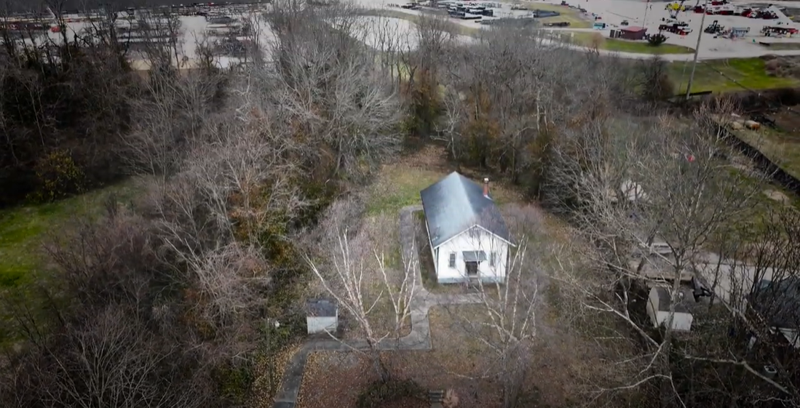
Image D: Drone photo of property

