August 1, 2026

LexArts
161 N. Mill Street
Lexington, KY 40507

Dear Grants Committee:

I wish to express enthusiastic support for the Cadentown School Project proposal submitted by A Sense of Place in Fayette County, Kentucky. A Sense of Place is a community initiative aimed at commemorating and telling the story of the rural African American hamlets of Fayette County. The Cadentown School Project is crucial for the preservation of a Rosenwald school building in the hamlet of Cadentown, in eastern Fayette County. I have examined the proposal closely and believe the scope of work and budget are realistic and appropriate. I endorse the proposal wholeheartedly and encourage you to give it careful consideration. Funding for A Sense of Place will make possible the rehabilitation of an important African American heritage site and facilitate interpretation of rural African American life in central Kentucky during the nineteenth and twentieth centuries.

In the 1960s, scholars identified African American hamlets throughout central Kentucky as a distinctive type of rural community. Although some hamlets originated as free Black communities during the antebellum era, most developed after the Civil War, when newly emancipated African Americans sought landownership and autonomy and large landowners needed agricultural labor. Small settlements developed on the periphery of large farms throughout the Bluegrass region. Most centered on churches, schools, and lodge halls. In many cases, former slaves worked for their former masters, living on lands near their former places of enslavement while forging independent lives. In recent year, hamlets in Woodford, Scott, Fayette, and Jessamine counties have become the focus of preservation campaigns and heritage celebrations.

A Sense of Place has accomplished a great deal in a relatively short period of time. The initiative has received strong support from the public, corporate sponsors, philanthropic organizations, and the Lexington-Fayette Urban County Government (LFUCG). Partnerships with the University of Kentucky and the Lexington History Museum have assisted in conducting research, collecting oral histories, and gathering historical photographs, artifacts, and ephemera. Public outreach and engagement have tapped into a rich network of former residents, relatives, and descendants.

Plans call for renovating the Rosenwald School building (1923) at Cadentown for use as a cultural and interpretive center. The rehabilitated building will house artifacts and exhibits, host educational tours, and provide space for community meetings. A Sense of Place plans to renovate the building in accordance appropriate standards and make it ADA accessible. The structure is owned by the LFUCG, which ensures general upkeep and maintenance.

Funding from LexArts will assist A Sense of Place in renovating the building and working toward its plans to deliver historical and cultural programs. To date, research has identified twenty hamlets in Fayette County. The rehabilitation of the Rosenwald School will thus aid in telling the history of African American life throughout the county and connecting it to major themes in American history.

Sincerely,
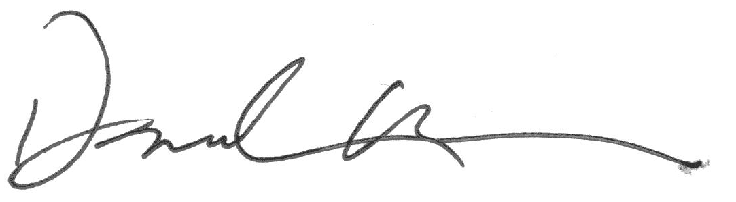
Daniel Vivian
Associate Professor

