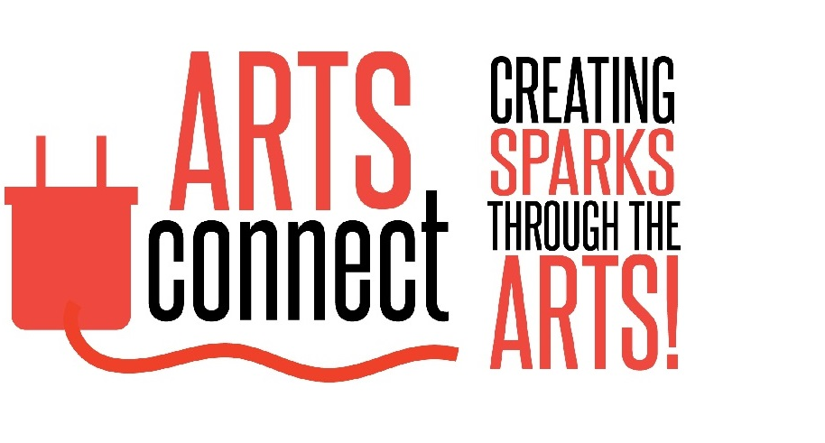
Thursday, 6th August 2026

LexArts Grants Committee,

I am pleased to offer my enthusiastic support for Elevate Arts KY and its proposed Elevate LEX Showcase.

At ArtsConnect, our mission has always been to connect people with the arts while strengthening awareness of the remarkable creative organizations that make Lexington such a vibrant community. One of the greatest opportunities before us is not simply presenting outstanding artistic work, but helping arts organizations work together to expand their collective reach and impact.

That is what makes the Elevate LEX Showcase so compelling.

Rather than highlighting a single organization, the Showcase is designed to bring together a diverse cross-section of Lexington’s arts community, introducing audiences to organizations they may not otherwise experience. When supporters of one organization discover another, everyone benefits. New relationships are formed, audiences broaden, volunteers become engaged, and opportunities grow for increased patronage, philanthropy, and long-term community support.

For arts organizations like ArtsConnect, this collaborative model reflects exactly the kind of ecosystem our community needs. By celebrating many artistic disciplines together, we create greater visibility for local artists while encouraging residents to experience the full breadth of Lexington’s creative community. The Showcase demonstrates how collaboration can strengthen every participating organization rather than asking them to compete for attention.

Equally important, the Showcase offers the community a tangible glimpse of what Elevate LEX can become. The organizations participating are not simply performers or exhibitors for a single event; they represent many of the future users of the facility. The Showcase illustrates how dedicated galleries, educational spaces, rehearsal rooms, performance venues, and community gathering spaces can serve as shared resources that foster creativity, partnership, and civic engagement throughout the year.

Lexington’s arts community is strongest when we champion one another. Elevate Arts KY’s vision creates opportunities for organizations to learn from each other, support one another, and collectively inspire broader community participation in the arts. I believe the Showcase will be an important step toward that future and a meaningful demonstration of the collaborative spirit that Elevate LEX seeks to cultivate.

ArtsConnect is pleased to support this effort and looks forward to opportunities to collaborate as the vision continues to grow.

Sincerely,

Kate Savage
Founder
ArtsConnect

