Tax I.D. 61-1145155
P.O. Box 910666
Lexington, KY 40591-0666 Website: biacs.org
Bluegrass Indo-American Civic Society
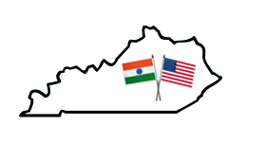

Executive Committee

President:
Raju Alluri

President Elect:
Dr. Zain Gudur

Treasurer:
Tripti Kedia

Secretary:
Trisha Dang

Past-president:
Naveen Gupta

Councilors:
Raja Ravipati
Dr. Praveen Kumar
Dr. Deepshika Gupta

Fundraising Chair
Shobana Venkatesan

Scholarship Committee Chair
Dr. Subba Reddy Palli

